APPLIED MATHEMATICS PROJECT

NAME: ADITHYA VENKATRAMANAN

CLASS: 12

SECTION: F

ROLL NUMBER: 3

BOARD ROLL NUMBER:

YEAR: 2021-22

TEACHER-IN-CHARGE: MR. GURPREET SINGH

TOPIC: ANALYSIS OF CAREER GRAPH OF A CRICKETER

ACKNOWLEDGEMENT

I thank the mathematics department of our school for giving us this opportunity to present this project. I also thank my applied mathematics teacher Mr. Gurpreet Singh for his guidance towards the completion of this project successfully and I also appreciate my parents for their all-time support.

INDEX

S.NO | TOPIC | PG NO.
1 | ABOUT THE BATSMAN | 4
2 | MS DHONI’S CAREER SUMMARY DATA | 5
3 | GRAPHICAL REPRESENTATION OF THE DATA | 5-8
4 | OBSERVATION | 9
5 | YEAR-WISE GRAPHS OF TEST CRICKET, ODI AND T20I MATCHES WITH OBSERVATION | 10-18
6 | CONCLUSION | 19

ABOUT THE BATSMEN

Mahendra Singh Dhoni, a former Indian international cricketer, held the captaincy of the Indian national team in limited-overs formats from 2007 to 2017, and in Test cricket from 2008 to 2014.
Dhoni's leadership saw India triumph in two World Cups. Notably, he led the team to victory in the 2011 World Cup and guided them to the semifinals in 2015.
From a humble start as a ticket-collector at Kharagpur Railway Station, Dhoni transformed into an iconic captain known for his composed demeanour. He earned the moniker of "captain cool" and gained recognition as one of the greatest finishers in limited-overs cricket. His influence sparked a paradigm shift, placing emphasis on batsmen's ability to achieve improbable run chases.
Outside international cricket, Dhoni continues his cricket journey as a key player and captain of the Chennai Super Kings in the Indian Premier League.
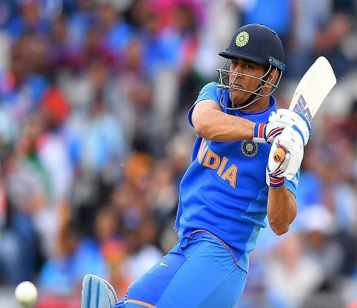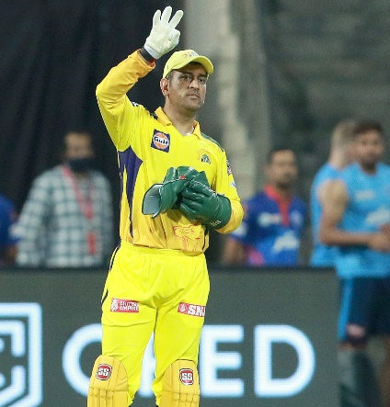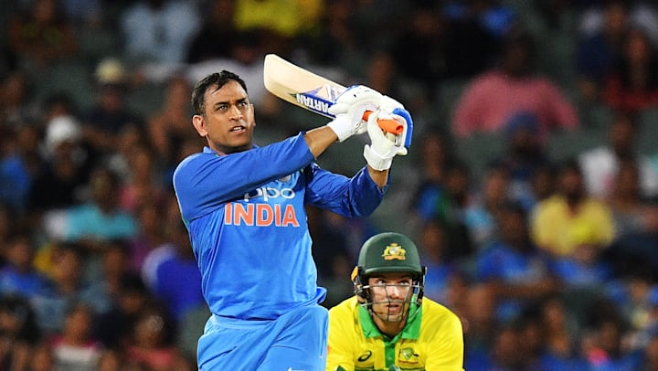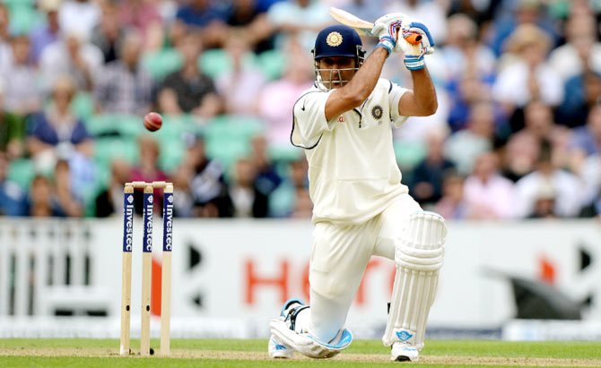

MS DHONI’S CAREER SUMMARY DATA

 | M | Inn | NO | Runs | HS | Avg | BF | SR | 100 | 200 | 50 | 4s | 6s
Test | 90 | 144 | 16 | 4876 | 224 | 38.09 | 8248 | 59.12 | 6 | 1 | 33 | 544 | 78
ODI | 350 | 297 | 84 | 10773 | 183 | 50.58 | 12303 | 87.56 | 10 | 0 | 73 | 826 | 229
T20I | 98 | 85 | 42 | 1617 | 56 | 37.6 | 1282 | 126.13 | 0 | 0 | 2 | 116 | 52
IPL | 211 | 186 | 70 | 4669 | 84 | 40.25 | 3417 | 136.64 | 0 | 0 | 23 | 317 | 217
GRAPH ON NUMBER OF MATCHES PLAYED

GRAPH ON NUMBER OF INNINGS PLAYED

GRAPH ON NUMBER OF NOT OUTS

GRAPH ON NUMBER OF RUNS SCORED

GRAPH ON HIGHEST RUNS SCORED

GRAPH ON AVERAGE RUNS SCORED PER MATCH

GRAPH ON BALLS FACED

GRAPH ON STRIKE RATE

GRAPH ON 100+ AND 200+ RUNS SCORED

GRAPH ON 50+ RUNS SCORED

GRAPH ON 4’S AND 6’S HIT

OBSERVATION

BACKGROUND: MS Dhoni has played the most of number of matches in One Day International followed by IPL. Currently, he plays only in the IPL as the captain of Chennai Super Kings. His batting position is generally at Number 4, although he is placed down the order in Indian Premier League due to the number of batsmen available to the franchise.

OBSERVATION FROM GRAPHS: MS Dhoni is most successful in One Day International games as he has scored the most number of runs in the series compared to the others. But this may be due to the higher number of opportunities/matches he has played. He has scored the most number of 4’s and 6’s, 50+ and 100+ in ODI Series as well. His Strike Rate is higher for IPL than in ODI which is quite natural as IPL requires power-hitters due to the intense game of twenty overs. But the strike rate, 4’s and 6’s and 50+ in IPL is still higher compared to T20I which can be related to the number of balls faced. He has played actively for the franchise and thus shows the opportunities he has been given in the IPL than that given in T20I to showcase his talent.



The next part of the project will focus on the year-wise achievements of MS Dhoni and the project will conclude the best year of his career.

TEST MATCHES

Year | Innings | Runs | Balls | Outs | Avg | SR | HS | 50 | 100 | 4s | 6s | Dot %
2005 | 5 | 149 | 199 | 4 | 37.2 | 74.9 | 51 | 1 | 0 | 20 | 2 | 64.3
2006 | 19 | 557 | 778 | 19 | 29.3 | 71.6 | 148 | 2 | 1 | 76 | 12 | 69.5
2007 | 13 | 468 | 690 | 9 | 52.0 | 67.8 | 92 | 5 | 0 | 52 | 10 | 65.7
2008 | 19 | 633 | 1,206 | 18 | 35.2 | 52.5 | 92 | 6 | 0 | 60 | 8 | 72.4
2009 | 6 | 369 | 623 | 4 | 92.2 | 59.2 | 110 | 2 | 2 | 34 | 8 | 69.7
2010 | 19 | 749 | 1,350 | 18 | 41.6 | 55.5 | 132 | 4 | 1 | 79 | 11 | 70.0
2011 | 21 | 511 | 880 | 19 | 26.9 | 58.1 | 144 | 3 | 1 | 47 | 10 | 68.3
2012 | 13 | 447 | 908 | 11 | 40.6 | 49.2 | 99 | 5 | 0 | 45 | 8 | 74.9
2013 | 12 | 459 | 634 | 10 | 45.9 | 72.4 | 224 | 0 | 1 | 56 | 6 | 65.1
2014 | 17 | 534 | 981 | 16 | 33.4 | 54.4 | 82 | 5 | 0 | 76 | 3 | 76.2

- The most important aspect as far as a Test Match is concerned is Dot %, Contribution to the team i.e. Highest Score and Balls Faced, as Test Cricket focuses more on Survival and Patience.

As far as runs are concerned, Dhoni’s best year was 2009 during his test career. He had an average of 94.2 due to the two centuries that he scored against the test match in Sri Lanka. However, the data clearly shows that he had played only 6 innings in total, thus keeping the average high.
On the other hand, when we compare the data of 2010, average, innings played, runs scored and dot % clearly show that Dhoni’s best year in his Test Career was in 2010.

ODI MATCHES

Year | Innings | Runs | Balls | Outs | Avg | SR | HS | 50 | 100 | 4s | 6s | Dot %
2004 | 3 | 19 | 14 | 2 | 9.5 | 135.7 | 12 | 0 | 0 | 2 | 1 | 42.9
2005 | 24 | 895 | 870 | 18 | 49.7 | 102.9 | 183 | 3 | 2 | 67 | 34 | 47.9
2006 | 26 | 821 | 883 | 20 | 41.0 | 93.0 | 96 | 7 | 0 | 81 | 20 | 51.3
2007 | 33 | 1,103 | 1,231 | 25 | 44.1 | 89.6 | 139 | 7 | 1 | 87 | 23 | 45.8
2008 | 26 | 1,097 | 1,333 | 19 | 57.7 | 82.3 | 109 | 8 | 1 | 74 | 14 | 49.4
2009 | 24 | 1,198 | 1,400 | 17 | 70.5 | 85.6 | 124 | 9 | 2 | 79 | 18 | 45.6
2010 | 17 | 600 | 760 | 13 | 46.2 | 78.9 | 101 | 3 | 1 | 52 | 9 | 52.1
2011 | 22 | 764 | 850 | 13 | 58.8 | 89.9 | 91 | 6 | 0 | 59 | 14 | 46.8
2012 | 14 | 524 | 598 | 8 | 65.5 | 87.6 | 113 | 3 | 1 | 37 | 9 | 48.0
2013 | 20 | 753 | 784 | 12 | 62.8 | 96.0 | 139 | 5 | 1 | 67 | 24 | 50.0
2014 | 10 | 418 | 454 | 8 | 52.2 | 92.1 | 79 | 5 | 0 | 32 | 11 | 47.1
2015 | 17 | 640 | 737 | 14 | 45.7 | 86.8 | 92 | 4 | 0 | 50 | 11 | 47.6
2016 | 10 | 278 | 347 | 10 | 27.8 | 80.1 | 80 | 1 | 0 | 18 | 9 | 53.6
2017 | 22 | 788 | 930 | 13 | 60.6 | 84.7 | 134 | 6 | 1 | 60 | 19 | 50.1
2018 | 13 | 275 | 385 | 11 | 25.0 | 71.4 | 42 | 0 | 0 | 19 | 2 | 52.2
2019 | 16 | 600 | 729 | 10 | 60.0 | 82.3 | 87 | 6 | 0 | 42 | 11 | 50.9

- ODI Matches require a balanced strike rate, power-hitting in the last 10 overs, scoring runs and maintaining a good average.

- Again, the graphs depict clearly that 2009 seems to be the best year in his One Day International Career.
- He scored the highest number of 50’s and maintained a posh average of 70.5 runs, and 1198 runs in total (highest in his career in ODI).
- After all, he has played 24 innings and maintained an excellent average of 70.5.

T20I MATCHES

Year | Innings | Runs | Balls | Outs | Avg | SR | HS | 50 | 100 | 4s | 6s | Dot %
2006 | 1 | 0 | 2 | 1 | 0.0 | 0.0 | 0 | 0 | 0 | 0 | 0 | 100.0
2007 | 7 | 163 | 125 | 5 | 32.6 | 130.4 | 45 | 0 | 0 | 13 | 4 | 26.4
2008 | 1 | 9 | 27 | 1 | 9.0 | 33.3 | 9 | 0 | 0 | 0 | 0 | 66.7
2009 | 10 | 184 | 182 | 8 | 23.0 | 101.1 | 46 | 0 | 0 | 10 | 3 | 35.2
2010 | 5 | 85 | 57 | 2 | 42.5 | 149.1 | 29 | 0 | 0 | 3 | 6 | 29.8
2011 | 3 | 39 | 45 | 2 | 19.5 | 86.7 | 21 | 0 | 0 | 1 | 1 | 44.4
2012 | 12 | 268 | 213 | 5 | 53.6 | 125.8 | 48 | 0 | 0 | 24 | 6 | 36.6
2013 | 1 | 24 | 21 | 0 | - | 114.3 | 24 | 0 | 0 | 2 | 0 | 23.8
2014 | 5 | 77 | 58 | 1 | 77.0 | 132.8 | 27 | 0 | 0 | 4 | 4 | 34.5

- As far as T20I matches are concerned, innings played, runs scored, high strike rate and highest score matters the most.

- The graphs clearly depict that 2012 is the best year of MSD’s career for T20I.
- Except the strike rate, as most number of innings played affects the strike rate, all the other graphs show positively for 2012 for him as a player. However, India couldn’t win the World Cup in 2012 due to poor bowling performance shown by the team. Most importantly, cricket is a sport of coordination, one man cannot steal the show.

CONCLUSION

This project has helped me to increase my knowledge on using MS Excel as a powerful statistical tool for making graphs. I also learnt to interpret the data from the graphs and draw meaningful conclusions. Also, I could increase my statistical knowledge by reviewing bar charts and line charts which were taught in previous grades.

BIBLIOGRAPHY

- https://www.espncricinfo.com/player/ms-dhoni-28081
- http://www.cricmetric.com/playerstats.py?player=MS%20Dhoni&format=all&role=all
- https://en.wikipedia.org/wiki/MS_Dhoni

